No 523 Sat. 19.9.98 Warm & sunny after a foggy start.

Len Wise, Hamish Dublon, Sarah Belson + me = 4. (Dave Bevan joined us for a couple of hours).

We cordoned-off areas of scrub and areas containing dead wood in order that they would not be disturbed by the tree-clearance work destined for the first week of October. We also took 360 deg. panoramas for Hamish’s “virtual Heath” computer plan.

It was lovely to see Sarah back with us for a “one-off” after an absence of at least three years. Just a shame most of the Group were on a field trip in Ireland. Boy, was it quiet !!
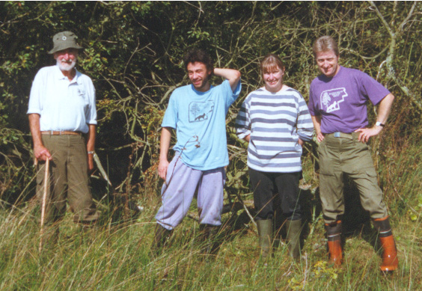
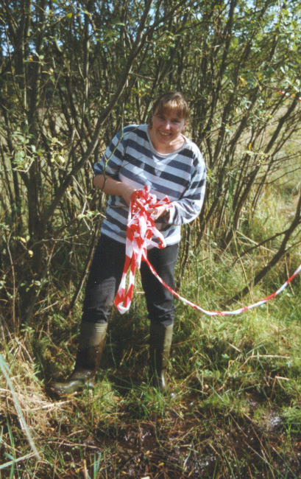
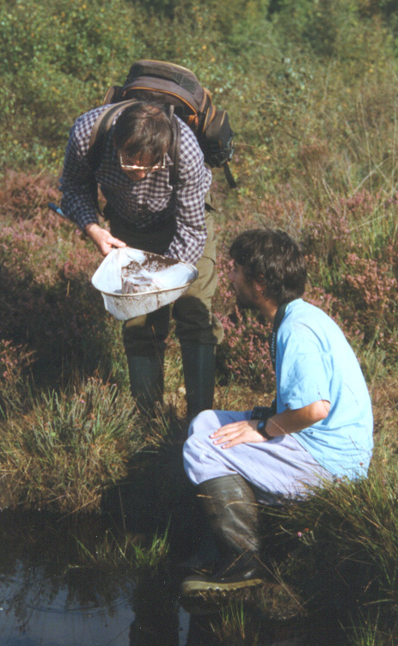
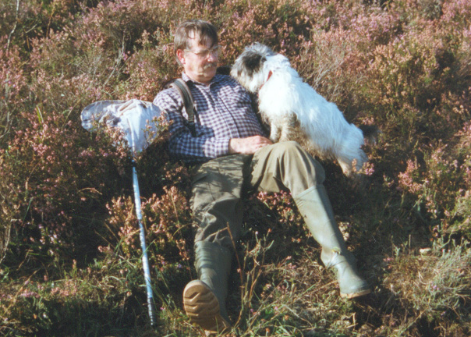
...........................................................................................................

Birds: Green Woodpecker Picus viridis, Great Spotted Woodpecker Dendrocopos major, Jay Garrulus glandarius, Magpie Pica pica, Kestrel Falco tinnunculus - D25.

Odonata: Common Darter Sympetrum striolatum, Southern Hawker Aeshna cyanea.

Hemiptera: Common Backswimmer Notonecta glauca (B11 pools - flew out of net across the heath !

Coleoptera: ?? Diving Beetle ?? - B11 pools.

Butterflies: Large White Pieris brassicae, Brimstone Gonepteryx rhamni (male), Peacock Inachis io, Speckled Wood Pararge aegeria.

Herptiles: Common Frog Rana temporaria, Common Toad Bufo bufo, Common Lizard Lacerta vivipara ( E18 - adult & juvenile ).

In flower: Devil’s-bit Scabious Succisa pratensis, Tormentil Potentilla erecta, Grass of Parnassus Parnassia palustris, Marsh Marigold Caltha palustris, Eyebright Euphrasia officinalis agg., Ling Calluna vulgaris, Cross-leaved Heath Erica tetralix, Bell Heather E. cinerea, Western Gorse Ulex gallii.



